Virginia Election Recounts
Step-by-Step Instructions

Includes:

- Overview of Recounts and Contests
- Preparations for the Recount
- Precinct Instructions for Recount Coordinators and Officials-All Voting Systems
- Suggested Steps for the Court's Review and Compilation of Recount Results
- After the Recount

Table of Contents
A Message to General Registrars and Electoral Board Members 3
Overview -- Election Recounts and Contests 3
Recounts 3
Contests 4
Preparations for the Recount 7
Department of Elections, General Registrar(s), and Electoral Board Members 7
Duties of Clerk(s) of Court 7
Duties of the Chief Judge of the Recount Court 8
Duties of the Recount Court 8
Terminology 8
"Part One" - Recount Day in the City or County 9
Check in and Logistics 9
Precinct Instructions for Recount Coordinators & Officials - All Voting Systems 9
Materials 9
General Instructions 11
A. Preparing for and Evaluating Machine-readable Ballots 13
B. Count the paper ballots 18
C. One precinct at a time, Open Envelope #2; Record DRE Results 20
D. Paper Pollbooks: Verify pollbook count and number of paper ballots cast 23
E. Electronic Pollbooks: Verify pollbook count and number of paper ballots cast 26
F. Finish the paperwork 27
G. Repeat for next precinct 29
Finishing the Locality's Results; Sealing and Delivery of Material 30
"Part Two" - Court Review and Compilation of Results -- Suggested Steps 32
Check in and Logistics 32
Officials and Authorized Representatives 32
Floor Team Step-by-Step 33
Guidelines 33
Review and Compilation of Results 33
Dealing with Challenged Ballots 34
Final Certification of Results: Re-seal material 35
After the Recount 36
Issuance of Certificate of Election 36
Update Results on Department of Elections Website 36
Return and Final Retention of Material 36

A Message to General Registrars and Electoral Board Members

Please carefully review this document as soon as you know that a recount is possible in one of your elections. Also provide a copy to your local Clerk of Court. These instructions accompany the RECOUNT PRECINCT RESULTS For All Voting Systems (form SBE-802-PR )

If you have any questions about this information, please do not hesitate to contact a Department of Elections policy analyst.

Overview -- Election Recounts and Contests

Recounts
A recount is a simple redetermination (retabulation) of all of the votes cast on Election Day. Recount officials only count the ballots that were previously cast. A voter’s eligibility to vote or any alleged irregularities cannot be called into question during a recount (only in a contest, see below).

In Virginia, there are no automatic recounts. Only an apparent losing candidate can ask for a recount, and only if the difference between the apparent winning candidate and that apparent losing candidate is not more than one percent (1%) of the total votes cast for those two candidates.

As of 2009, a losing candidate may request a recount if the difference is not more than five percent (5%) of the total votes cast for those two candidates if one of those candidates was a write-in candidate for that office. (§ 24.2-800, Code of Virginia)

The apparent losing candidate cannot request a recount until after the election is certified. (§ 24.2-801) The Department of Elections certifies primary and election results for all federal offices (Presidential Electors, U.S. Senate, and U.S. Congress), state offices (Governor, Lt. Governor, and Attorney General and General Assembly seats) and any offices shared by two or more localities.

An apparent losing candidate requesting a recount of a primary or general election for statewide office files the petition requesting a recount with the Circuit Court of the City of Richmond. A candidate requesting a recount for any other office files the recount petition with the Circuit Court where the candidate being challenged resides.

Local electoral boards certify all other election results for local offices. Each electoral board meets in the days following the election to canvass and certify these results. To request a recount, an apparent losing candidate for a local election must file a petition for a recount with the Circuit Court where the challenged candidate resides within ten days after the electoral board certifies the election results. Any local candidate seeking a recount should check with their local general registrar or electoral board to determine the actual date of certification for these local offices.

The Chief Judge of the Circuit Court where the recount petition was filed and two other judges appointed by the Chief Justice of Supreme Court of Virginia make up the recount court. The recount court, outlines all procedures and the manner in which the recount will be conducted for each type of voting equipment used (pursuant to § 24.2-802 of the Code of Virginia).

The recount court appoints recount officials from among the officers of election who served in the locality during the election. These recount officials are appointed to represent the respective parties to the recount. In setting the procedures for the recount, the court will also decide if the actual recounting of votes cast will take place in the various localities or in a central location. After all of the votes cast are recounted, the court will certify the candidate with the most votes as the winner.

The counties and cities involved in a recount are responsible for paying their own costs for the recount if the margin between the two candidates who are parties to the recount is one-half percent or less, or if the candidate requesting the recount is declared the winner by the recount court. Otherwise, the candidate who requested the recount must pay the costs for conducting the recount. Any candidate requesting a recount who may be assessed with costs shall post a bond with surety with the court in the amount of $10 per precinct in the area subject to the recount. (More information about recount costs is available in § 24.2-802(E) and (F) of the Code of Virginia).

Because of the federal deadline for the seating of the state's presidential electors, Virginia law provides an accelerated schedule for any recount of such election (see § 24.2-801.1). The presidential candidate represents the vice presidential candidate and the candidates for electors (§ 24.2-800). The deadline for filing of notice of intent to contest is 5:00 PM on the second calendar day following certification of the election by the Department of Elections. The recount "shall be held promptly" and must be concluded at least six days before the time fixed for the convening of the electors. If a contest of an election for Virginia's presidential electors is also filed, they would proceed simultaneously (§ 24.2-805).

Contests
An unsuccessful candidate in the election may file a notice of intent to contest the election. The notice must state the grounds for the contest, which must include one of the following:
(i) objections to the eligibility of the contestee based on specific allegations, OR
(ii) objections to the conduct or results of the election accompanied by specific allegations which, if proven true, would have a probable impact on the outcome of the election, OR
(iii) both.

Contests of elections for most offices in Virginia may be filed only within 30 days of the election or 10 days of the date of the primary or a special election held on a date other than that of a general election. A contest may also be filed after a recount under Va. Code § 24,2-814 within 10 days after the recount court’s order declaring a winner under Va. Code § 24.2-802(D).

If a recount has been held for an election to the House of Delegates, State Senate, Governor, Lieutenant Governor, or Attorney General, the apparent losing candidate for that office who also loses the recount has until 3 days after the conclusion of the recount (or 30 days after Election Day, whichever date is later) to file notice of intent to contest. A candidate who was originally declared the winner and loses as a result of a recount may file notice of intent to contest the election within 10 days following the conclusion of the recount.

In elections for a Member of the U.S. Senate or U.S House of Representatives,
Article I, section 5 of the U.S. Constitution provides that "Each House shall be the Judge of the Elections, Returns and Qualifications of its own Members." Article IV, section 7 of the Virginia Constitution has a nearly identical provision. Virginia Code § 24.2-803 requires that contests for elections of General Assembly members must be filed with the respective clerks for decision by the affected body.

To contest an election for the House of Representatives, a notice of intent to contest the election must be filed with the Clerk within 30 days after the result of the election has been certified by the Department of Elections, or if there is a recount, within 30 days after the recount court certifies the election result. (2 USC Chapter 12, particularly Sections 384 and 392)
The contestant "would have to formally petition the U.S. Senate for a probe into the election, and the Rules Committee has broad authority to investigate election cases, including conducting its own recount. The Rules panel, however, would have to vote to begin the inquiry, and historically, those probes have taken months if not years to complete. Any findings — such as whether an election was legitimate — would be forwarded to the full Senate with a recommendation on what, if any, action to take, which the Senate could then decide whether to take up." A deadline for filing such a contest is not stated in federal law.
As with recounts of elections for presidential electors, Virginia law provides an accelerated schedule for any contests of such presidential elections as well. The presidential candidate represents the vice presidential candidate and the candidates for electors (§ 24.2-807). The deadline for filing of the notice of intent to contest is 5:00 PM on the second calendar day following certification of the election by the Department of Elections. The contest "shall not wait upon the results of any recount" and must be concluded at least 6 days before the time fixed for the convening of the electors (§ 24.2-805). Any recount or contest for an election for presidential electors would proceed simultaneously.
Office | Notice of intent to contest is filed with
Election of Presidential Electors | Circuit Court, City of Richmond
Primary for U.S. Senate or Statewide Office | Circuit Court, City of Richmond
Presidential Primary | No contest provisions in Code of Virginia
Election for Governor, Lt. Governor or Attorney General | Clerk of the House of Delegates
Election for House of Delegates | Clerk of the House of Delegates
Election for State Senate | Clerk of the State Senate
Primary for U.S. House of Representatives, House of Delegates or State Senate | Circuit Court where challenged candidate resides
Primary or Election for any county, city, town or district office | Circuit Court where challenged candidate resides

Persons Involved in the Recount

Electoral Boards – Give court and parties a list of all Officers of Election who served in the last election, with their party affiliations, etc. One electoral board member representing each party will be selected by the Recount Court to serve as one of the pair of Recount Coordinators for the locality.

Recount Officials – Each candidate or petitioner and governing body/chief executive officer (in the case of a referendum) involved in the recount may select an equal number of officers of election to serve as recount officials. Recount officials have the duty of counting the ballots, or redetermining the vote (if DREs). Recount officials will work in groups or pairs with the parties to the recount being equally represented.

Registrars – Permit parties to make copies of statements of results, machine tapes, printed return sheets, pollbooks (whether paper or in electronic format), and abstract of votes (original and corrected) for the election at issue, etc.

Recount Court – Upon receipt of the petition for recount, the Chief Judge of the court in which it was filed must alert the Chief Justice of the Virginia Supreme Court, who will thereafter appoint two judges to serve on the Recount Court. These three judges will constitute the Recount Court. The Recount Court will determine the procedures to be followed during the recount, what information will be accessible to the parties, and for which candidate, if any, a challenged ballot should be counted.
Clerks of Court – Secure election materials and certify security to recount court; be present and administer oaths on the day of the recount; deliver election materials to State Police after the recount for delivery to the Court.

Clerk of Recount Court – In addition to duties of all clerks (above), summons Recount Officials and is present at all hearings of the Recount Court.

Candidates – May be present. They are responsible for selecting which officers of election will serve as the recount officials representing their interest, based on the number established by the Recount Court. They may also send one authorized representative per team of recount officials to observe the process.

Preparations for the Recount

Department of Elections, General Registrar(s), and Electoral Board Members
The Department of Elections' Standards for Recounts in Virginia Elections (and accompanying Ballot Examples) provides details and guidance to help carry out Virginia's recount laws (§§ 24.2-800 - 24.2-802). The Code of Virginia directs:
A. The Department of Elections shall promulgate standards for (i) the proper handling and security of voting and counting devices, ballots, and other materials required for a recount, (ii) accurate determination of votes based upon objective evidence and taking into account the counting device and form of ballots approved for use in the Commonwealth, and (iii) any other matters that will promote a timely and accurate resolution of the recount. The chief judge of the circuit court or the full recount court may, consistent with Department of Elections standards, resolve disputes over the application of the standards and direct all other appropriate measures to ensure the proper conduct of the recount.
The recount procedures to be followed throughout the election district shall be as uniform as practicable, taking into account the types of ballots and voting devices in use in the election district. (§ 24.2-802)
As soon as it appears that a recount in a local, district, or state election may be possible, the General Registrar and Electoral Board Members from the impacted locality(ies) must begin making preparations.
Electoral Boards should first create a list of names of officers of election who served in the precincts subject to the recount. The political parties involved in the recount need this list to appoint recount officials from this group of officers of election. The number of recount officials necessary will be determined by the Recount Court.

General registrars should also begin assembling all appropriate forms for conducting the recount and ensure that these forms are delivered to the Recount Coordinators.

Duties of Clerk(s) of Court
Section § 24.2-802 of the Code of Virginia directs the Clerks of Court in a jurisdiction where there may be a recount to secure the ballots and election materials until the recount. This should be done under normal circumstances, but it is added into the recount laws for emphasis. Also, the Clerk is required to certify to the chief judge in the recount, as directed, that the proper security measures have been taken.

In preparation for the recount, the clerks of the circuit courts shall (a) secure all printed ballots and other election materials in sealed boxes; (b) place all of the sealed boxes in a vault or room not open to the public or to anyone other than the clerk and his staff; (c) cause such vault or room to be securely locked except when access is necessary for the clerk and his staff; and (d) certify that these security measures have been taken in whatever form is deemed appropriate by the chief judge. (§ 24.2-802(A))

Duties of the Chief Judge of the Recount Court
The Chief Judge must hold a preliminary hearing within 7 calendar days of the petition for recount unless the recount is requested for a presidential election, in which case it must be held within 5 calendar days. The Chief Judge will rule on motions and establish rules of procedure during the preliminary hearing, but such decisions are subject to review by the full Recount Court. The security measures adopted to secure materials after Election Day, and those going forward must be examined and established by the Chief Judge. The Chief Judge may also allow parties to examine election materials. The Chief Judge may also set the locations for the recount and may order the delivery of election materials to a central location, but such action is subject to review by the full Recount Court.

Duties of the Recount Court

Once established, the Recount Court will hold a hearing. All motions and rules of procedure shall be finalized at this hearing. The parties (or their counsel) shall meet and confer and submit a proposed “Recount Procedural Order” and eventual “Final Order” for consideration by the three-judge Recount Court. If the parties do not agree, they will file competing legal memoranda and proposed orders. The Recount Court will also allow parties to the recount to select an equal number of officers of election to be Recount Officials. The date for submissions will be included in the Preliminary Order by the Recount Court.

The three-judge Recount Court shall supervise the recount and redetermination of the vote, with assistance from the Department of Elections and the local electoral boards.

Terminology
Throughout this document the terms “machine-readable ballot,” “paper ballot,” and “printed ballot” are used to describe physical ballots. The usage of terms is consistent with the definitions provided in Va Code § 24.2-101:

"Machine-readable ballot" means a tangible ballot that is marked by a voter or by a system or device operated by a voter and then fed into and scanned by a counting machine capable of reading ballots and tabulating results;

"Paper ballot" means a tangible ballot that is marked by a voter and then manually counted; and

"Printed ballot" means a tangible ballot that is printed on paper and includes both machine-readable ballots and paper ballots.

A ballot’s designation is based on how it was counted on election day. A machine-readable ballot that is manually counted during the recount should not be tallied as a paper ballot upon the recount paperwork.

The terms “ballot scanner machine,” “ballot scanner,” and “scanner” are used interchangeably throughout this document and within the recount forms.

"Part One" - Recount Day in the City or County

Check in and Logistics
The offices or other facilities for the recount will be provided or arranged by the Clerks of Court and shall be of sufficient size for the purposes of the recount and shall allow for direct and proximate observation of the recount officials by the recount observers.
All participants at the recount, whether as officials or observers, should check in with the Clerk of Court, and a record should be kept of all attendees.

Precinct Instructions for Recount Coordinators & Officials - All Voting Systems
Use appropriate instructions for any combination of
- MACHINE-READABLE BALLOTS AND BALLOT SCANNER MACHINES
- DIRECT RECORDING ELECTRONIC (DRE) MACHINE PRINTOUTS
- PAPER BALLOTS

Each Recount Team will complete one precinct at a time, under the supervision of Recount Coordinators.

Materials
A copy of each of these instructions (SBE-802-SBS, this entire document) should have been provided previously to each Recount Coordinator and to the Clerk of Court.

The Recount Coordinators should have already provided a copy of the following to each Recount Official during training for the recount:

- The full section of this document titled "Part One" - Recount Day in the City or County" which includes the Precinct Instructions
- A sample copy of SBE-802-PR - Recount Precinct Results for All Voting Systems
- A copy of the Ballot Examples for Hand Counting Printed Ballots for Virginia Elections or Recounts

The following materials prepared for the recount must be provided for each precinct:

- SBE-802-PR - Recount Precinct Results for All Voting Systems (1 set per precinct. If no DRE was used in the precinct, the two pages with Parts B-1 through B-3 should not be provided to the Recount Officials. The other four pages will be used for all precincts.)
- SBE-802-CB - Challenged Ballot Forms (4 per page; multiple copies may be needed)
- Challenged Ballots envelope (have one per precinct on hand)
- SBE-802-MA - Precinct Manual Tally Sheet (an optional form that can be used when hand counting printed ballots) (4 or more copies per precinct recommended, to keep paper and machine-readable ballot counts separate, and so each officer can prepare tally while other officer counts ballots)
- The memory card, cartridge, or other data storage medium (one per precinct) that has been prepared especially for the recount if machine-readable ballots are to be rerun through a tabulator during the recount.
  - It is recommended that the prepared cards, cartridges, or media be placed in the custody of the Clerk, to be released to the Recount Coordinators one precinct at a time with the other materials below.

The following materials will be released by the Clerk of Court to a Recount Coordinator upon request, one precinct at a time. The Coordinator will deliver them to the Recount Team that will recount that precinct.

- Envelope #2 containing the
  - POLLBOOKS and POLLBOOK COUNT Forms (all divisions) (if paper pollbooks were used),
  - one copy of the Statement of Results with machine tapes attached (General Registrar will have the second copy, available for public inspection, after the canvass),
  - Write-Ins Certification (if cast on printed ballots or voting systems that do not include the names written-in and votes cast for each), and
  - Incident Report
- Box/Envelope #3 containing the COUNTED BALLOTS (Envelope 3 may be combined with Envelope 5 so as to also contain outside poll envelopes).

And the following envelopes if used in the election:
- Envelope #7B containing the voting equipment keys for scanners and DRE dial/touchscreen voting systems
- Envelope #7/7C containing the voting equipment keys and memory cartridges for AVC Advantage DRE equipment and the data storage units and seals for scanners and DRE dial/touch screen equipment;

If Machine-readable ballots are to be rerun through a tabulator during the recount

- The memory card, cartridge, or other data storage medium that will be used for the precinct, and has been prepared specifically for the recount.
  - It is programmed to count, as required by law, only the votes cast for the office or issue in question in the recount and to set aside all ballots containing write-in votes, overvotes, and undervotes for that office or issue for hand counting.
  - (If the card, cartridge, or medium could not be reprogrammed as required by the recount law, all machine-readable ballots for the precinct will be hand counted by the recount team.)
- One memory card, cartridge, or other data storage medium for each precinct will be used to recount the ballots cast at the polling places in the district (including absentee ballots if counted at the precincts).
- If a Central Absentee Precinct (CAP) was used, one memory card, cartridge, or other data storage medium will be used to count the machine-readable ballots of absentee voters whose ballots were originally handled by the tabulator for the CAP.
- NOTE: The memory card, cartridge, or other data storage medium used in the precinct (or Central Absentee Precinct) on Election Day to count machine-readable ballots will remain sealed and in the custody of the Clerk. It should not be needed during the recount.
- (Counted provisional votes, even if voted on machine-readable ballots, were originally hand counted by the electoral board and will be treated in the recount as paper ballots. Provisional Ballots will be counted as a separate precinct, which is the same manner in which they were originally counted after Election Day).

General Instructions
The Recount Officials will be divided into teams consisting of equal representatives for each party. Teams will be tasked with recounting printed ballots or redetermining votes cast on DREs. At least one team will insert ballots into electronic counting devices programmed to count only those votes cast for parties to the recount or for or against the question in a referendum recount.

There are only two Recount Coordinators appointed per locality. One Coordinator may need to supervise multiple teams. Coordinators may offer advice to the Recount Officials.

The Recount Officials may either enter the required data on the Recount Precinct Results form or may read each total aloud to the Recount Coordinator who will enter it and read it back for verification by the Recount Officials. (Recount Officials must sign the first page, certifying the precinct results for each precinct that they recount.)

Only the Recount Officials may handle ballots. Recount Coordinators will deliver sealed election materials from the Clerk of Court, and return the resealed materials, one precinct at a time.

Each party to the recount (candidate) is allowed one observer per recount team. The observer may stand behind or sit to the outside of the Recount Officials as they work and may only watch and take notes. Observers must be close enough to see and hear what is happening. No observer may handle ballots, election materials, or recount materials. If an Observer has a question, it should be directed to the supervising Recount Coordinator -- not the Recount Officials -- without disturbing the proceedings.

Members of the news media and the general public may also be in the room, but are not allowed to handle any official materials or disturb the proceedings in any way.

Some suggested table layouts --

1. Observer Official Official Observer
[-------------------Table---------------------]
[----------------------------------------------]
[----------------------------------------------]
[----------------------------------------------]

2. Official Official
Observer [------------Table----------] Observer
[----------------------------]
[----------------------------]

3. Official
[----Table-----] Official
Observer [---------------]
[---------------] Observer
[---------------]

For each precinct, the Recount Coordinators will ensure as the work progresses that the following data is entered on each form page as required work begins (if not previously entered):
1. The name of the county or city
2. The name/number of the precinct in which the election was conducted
3. The date of the election
4. The name of the office and the names of the two candidates involved in the recount (in the same order that they appeared on the ballot in the election)

The Recount Coordinators will provide the necessary materials to the Recount Officials, one precinct at a time.

Instructions for the SBE-802-PR – Recount Precinct Results

- A highlighted line ___________ indicates a number is to be filled in during this sequence of steps.
- A highlighted box with a hand and pencil means that this is a calculation.


A note inside the field/data box provides instructions or crosschecks:
- "Carry to C1(i)" means to copy that figure to line C1, Column (i) (Line numbers begin with the same letters as sections, so line C1 is in section C.)
- "Should = C1(ii)" is a crosscheck letting the official know that the numbers should be the same. (If not, the official should recheck data entry and math before going any further).
- "Line A2 Total" tells the source of the number for that box -- copy it from there.
- A column titled "calculation or source" identifies the math or source used to fill in the next column.
- And "=B4+B5" and "=B2-B3" are instructions to arrive at the calculated number.
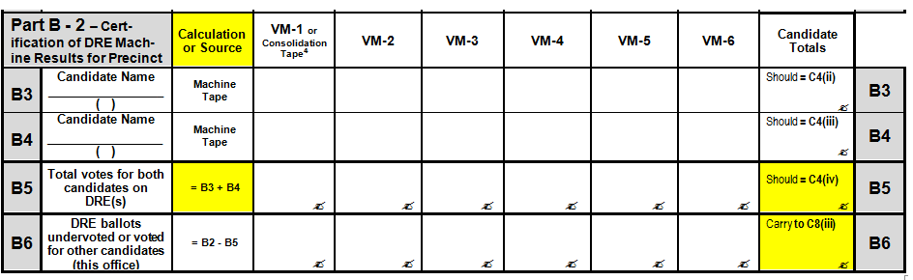

A. Preparing for and Evaluating Machine-readable Ballots
i. If Machine-readable ballots are to be rerun, prepare the ballot scanner machine.

1. Insert the MEMORY CARD, CARTRIDGE, OR OTHER DATA STORAGE MEDIUM for the precinct to be counted.

3. Turn the machine ON.

4. Produce a ZERO printout.

5. Verify that all totals on the ZERO printout, including the ballots cast, and the total on the Public Counter on the front of the machine read 0000.

6. Record the Serial Number from this scanner in the Recount Precinct Results, Part A, line A1 under “Scanner 1.”

7. Read the number from the Public Counter aloud and enter it in the Recount Precinct Results, Part A, line A3 ("Before Recount") under “Scanner 1.”

- If two scanners are used, repeat steps 1-7, filling in under “Scanner 2” for steps 6 and 7.

- Feed ballots.

ii. Insert Machine-readable ballots for precinct into ballot scanner machines

1. Open Box/Envelope #3 containing COUNTED BALLOTS for the precinct being counted.

2. As they are removed from the box/envelope, set aside the paper ballots for separate hand counting (face down); "Paper ballots" in a precinct that also uses ballot scanner machines may include:
- traditional paper ballots
- official reproductions of paper ballots or machine-readable ballots
- ballots sent to military or overseas voters by email or fax and printed by the voters (if absentee ballots are counted in the precinct -- or if precinct being recounted is the CAP)
- Federal Write-In Absentee Ballots (FWABs) from military or overseas voters (if absentee ballots are counted in the precinct -- or if precinct being recounted is the CAP). See 11.2.2010 Emergency Declaration of Secretary of Department of Elections.

All paper ballots were originally counted by hand, and must be recounted by hand, separately from the machine-readable ballots.

3. Feed all Machine-readable ballots into the scanner without examination of any ballot.

4. If the scanner indicates that for the office being recounted the ballot was overvoted or undervoted, or the ballot contains a write-in vote for that office, it must be separated out to be counted by hand. The scanner should have been programmed to reject these ballots so that they can separately hand counted. If so, simply set that ballot aside (face down) for hand counting.

If the machine is instead programmed to accept the write-in ballots, but automatically divert them into a separate “write-in” bin, do not include these ballots in the number provided on Line A5 for “Number of Manually Counted Machine-readable Ballots.” These ballots will be accounted for on paperwork in the total number of ballots scanned. The ballots must still be hand-counted the same as overvoted and undervoted ballots after separation, but should not be accounted for twice on the paperwork.

If any Machine-readable ballot is so damaged that the counting device will not accept it, it must also be set aside for hand counting.

5. Both Recount Officials must verify that the Box/Envelope #3 container is empty, that all Machine-readable ballots have been inserted in the scanner, and that all paper ballots have been set aside for separate hand counting.

6. Repeat steps 1 - 5 above for any additional Box/Envelope #3 containers of COUNTED BALLOTS for that precinct.

iii. Obtain results determined by the electronic counting device

1. When all Machine-readable ballots for the precinct have been inserted in the scanner, read the number from the Public Counter aloud and enter it in the Recount Precinct Results, Part A, line A2 ("After Recount"). Subtract line A3 from line A2, and enter it on the form in line A4 (public counter difference).

If two scanners are used, enter values for both “Scanner 1” and “Scanner 2.” Then add the values for “Scanner 1” and “Scanner 2” on line A2, and enter the total on line A2, under “Total (Scanner 1 + Scanner 2).” Repeat for lines A3 and A4.

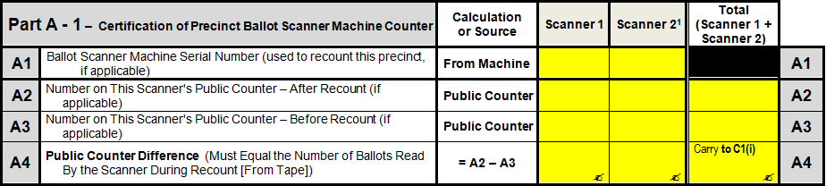

2. Run one printout to obtain the recount results for the precinct:

a) Produce the FINAL RESULTS tape.

b) Remove the MACHINE-READABLE ballots from the ballot compartments, return them to the COUNTED BALLOTS container(s), and seal it (them).

c) Remove the printout with ZERO report and the FINAL RESULTS intact.

3. Record the data from the ballot scanner machine tape on the Recount Precinct Results form:

- Enter the total Machine-readable ballots read in Part C, line C1, column (i). This number must match the public counter difference previously entered in Part A, line A4. If the numbers do not match, first recheck the counter numbers and number of ballots entered on the form, and the math. If they still do not match, ask for the advice of the Recount Coordinator.

- Read aloud the name of the first candidate involved in the recount and the number of votes cast for first candidate and enter the total in line C1, column (ii), double-checking that each number is copied to the column for the appropriate candidate.

- Read aloud the name of the second candidate involved in the recount and the number of votes cast for the second candidate and enter the total in line C1, column (iii), double-checking that each number is copied to the column for the appropriate candidate.

- Add together the number of machine-readable ballots counted by the scanner for both candidates and enter the total in line C1, column (iv).

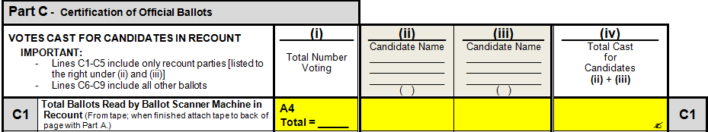

- Enter the precinct code on the BALLOT SCANNER MACHINE RECOUNT TAPE and staple it to the back (behind the top right) of the RECOUNT - PRECINCT RESULTS page containing Part A. (See instructions at the top of that page.)

iv. Hand count Machine-readable ballots previously set aside

Any Machine-readable ballots set aside from the steps above must be counted by hand.

A second team of Recount Officials may be used to count the ballots by hand.

- Count all set aside Machine-readable ballots (preferably with the office being recounted face down) without examining how they were cast. When both officials agree on the total count, enter the total on the Recount Precinct Results in Part A, line A5. Enter the same total in Part C, line C2, column (i).

(Remember that write-in ballots should not be included in this number if the scanner accepted the ballots and diverted them to a separate write-in bin).

(Remember that paper ballots must be counted separately. If any are found among the set aside Machine-readable ballots, put them with the other paper ballots.)

2. Examine each of the Machine-readable ballots to be counted and separate them into the following stacks (refer to the ballot examples in the “Hand Counting Printed Ballots for Virginia Elections or Recounts” if there is any question about how to count a mark).

During the sort, an official should lay each ballot face up on the table in the following stacks so that both officials and all observers can clearly see each ballot as it is sorted.

(1) and (2) One stack each for ballots clearly voted for either candidate involved in the recount

(3) Ballots either not voted for the office (undervoted) or not voted for candidates in the recount

(4) Ballots clearly voided by the voter for the office per § 24.2-663 (overvoted or title of office erased)

(5) Ballots challenged by either Recount Official (or the Officials cannot initially determine or agree how to count it)

After the first sort, re-examine the ballots in stacks 1-4 to make sure that each ballot is in the appropriate stack.

SBE-802-MA Precinct Manual Recount Tally Sheet is an optional form that may help Recount Officials when there are many ballots to hand count. If using it, complete the appropriate blanks/boxes at the top of the form and the candidates' names if not already completed. It covers each of the separate categories represented by the "stacks" and those counted/recorded in the procedures below. The final counts must still be recorded on the Recount Precinct Results form, as directed below.

The basic procedure for manually counting each stack (separately, when directed to do so below) is:
a. One Recount Official should count the ballots while the other closely observes.
b. Count the ballots by laying each ballot with the office being recounted face up on the table so that both officials and all observers can clearly see each ballot as it is counted.
c. Then the other official should count the same ballots while being closely observed by the first.
d. The official observing may use Department of Elections' Manual Recount Tally Sheet.
e. If the two officials do not arrive at the same number, repeat.

3. Re-examine all Machine-readable ballots in the "challenge" stack. Refer to the Ballot Examples. If the two Recount Officials agree on how to count the ballot, place the ballot in the appropriate other stack (1-4 above).

If both Recount Officials cannot agree, or they cannot determine how or whether to count a ballot, at least one of them must officially "challenge" the ballot.

a. For each challenged ballot, complete the form entitled STATEMENT OF RECOUNT OFFICIAL - CHALLENGED BALLOT (SBE-802CB), setting forth the reason(s) for the challenge. The officer challenging must sign the form and attach it to the ballot. This ballot will go to the Recount Court for a decision.

b. When all the ballots remaining in the "challenge" stack have been officially challenged, count the Machine-readable ballots being challenged and, when both officials agree on the number, enter total in Part C, line C9, column (i) of the Recount Precinct Results form.

c. Place the signed challenged ballot statements and attached ballots in the Challenged Ballots envelope for the precinct, and enter the name/number of the precinct. DO NOT enter the number of challenged ballots on the envelope at this time. DO NOT SEAL IT at this time. Set the envelope containing CHALLENGED BALLOTS aside.

4. Count all Machine-readable ballots overvoted or voided and, when both officials agree on the count, enter total in line C7, column (i) of the Recount Precinct Results form. Return voided ballots to Box/Envelope #3.

5. Count all Machine-readable ballots not voted (undervoted) or not voted for candidates involved in the recount and, when both officials agree on the count, enter total in line C8, column (i). Return these ballots to Box/Envelope #3.

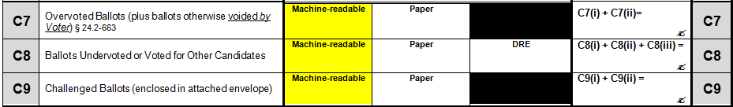

6. Now count the Machine-readable ballots voted for each of the two candidates in the recount (stacks 1 & 2). Count one candidate's ballots at a time.

When both officials agree on the count, enter each count on Line C3, in either Column (ii) or (iii), as appropriate of the Recount Precinct Results form, double-checking that each count is listed under the appropriate candidate.

7. Add together the number of Machine-readable ballots voted for both candidates and enter the total in line C2, column (iv).

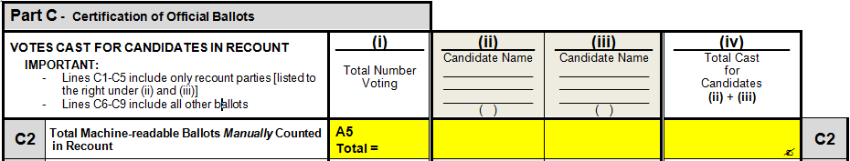

B. Count the paper ballots

Take the paper ballots that were set aside as they were removed from Box/Envelope #3 and count the paper ballots as follows.

If a second team of Recount Officials was used to count the Machine-readable ballots by hand, this second team should also count the paper ballots.

1. Count all paper ballots that have the office being recounted listed without examining how or whether the voter voted for the office. When both officials agree on the total number, enter the total in Part C, line C3, column (i) of the Recount Precinct Results form.

Enter the same number in Part A, line A6.

2. If the number entered in Part A, line A6 is not the same as the numbers entered in A7 and A8, recount officials should explain the reasons for the difference -- as best they know or can determine -- on the reverse side of the page containing Part A. (For example, if the difference is due to X number of federal only ballots and the recount is for a state or local office.)

(Recent recount court orders have required all the pollbooks and ballots for the precinct to be referred to the court if the number of paper ballots actually cast is not the same as the number of paper ballots indicated on the pollbook. The Recount Coordinator should be immediately informed if the numbers are not the same, and will know if the court order in the current recount contains instructions regarding this matter.)

3. If the total number of paper ballots in Part A, line A6 does not exceed the total number voting by paper ballot in Part A, line A7, enter ZERO (0) in Part C, line C6, column (iv) (paper ballots drawn);

4. If the total number of paper ballots in Part A, line A6 exceeds the total number voting on paper ballots in Part A, line A7 and no error is found, first consult with your Recount Coordinator. Recent recount orders have directed that the materials be sent to the Recount Court in this situation, not drawn down. The Recount Coordinator will know if the court order in the current recount contains instructions regarding this matter. If the court order is silent on this situation, the following procedures must be followed (§ 24.2-662):

a. Return all paper ballots to a container.

b. Have one of the Recount Officials, blindfolded, draw out the number of paper ballots necessary to reduce the total number to the number reported voting on paper ballots.

c. Mark the drawn paper ballots "DRAWN AND NOT COUNTED", and return them to Box/Envelope #3. Enter number drawn in Part C, line C6, column (iv).

5. To count the paper ballots, follow the same procedures described above in Section A under "iv. Hand count Machine-readable ballots previously set aside" with the differences below. (The only difference for most of the "stacks" -- other than challenged ballots -- is where the information for the paper ballots is recorded on the Recount Precinct Results form.)

a. Place the signed, challenged ballot statements and attached paper ballots in the Challenged Ballots envelope for the precinct, and enter the name/number of the precinct if not previously entered. Enter the total number of challenged ballots (machine-readable and paper) on the envelope and complete any other information required. SEAL the Challenged Ballots envelope. Set the envelope containing CHALLENGED BALLOTS aside.

Enter the number of challenged paper ballots in Part C of the Recount Precinct Results form in line C9, column (ii) (paper).

b. Enter total number of paper ballots overvoted or voided in line C7, column (ii) of the Recount Precinct Results form. Return voided paper ballots to Box/Envelope #3.

c. Enter the total number of paper ballots not voted or not voted for candidates involved in the recount in line C8, column (ii). Return these paper ballots to Box/Envelope #3.

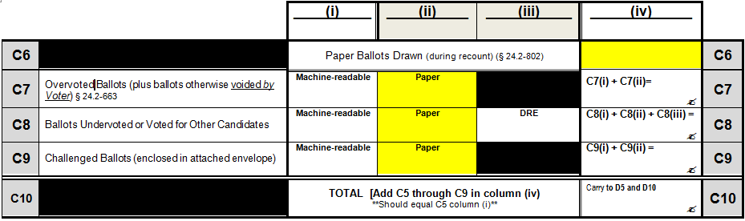

d. Now count the paper ballots voted for each of the two candidates in the recount (stacks 1 & 2). Count one candidate's ballots at a time.

When both officials agree on the count enter each count on Line C3, in either Column (ii) or (iii), as appropriate of the Recount Precinct Results form, double-checking that each count is listed under the appropriate candidate.

e. Add together the number of Paper ballots voted for both candidates and enter the total in line C3, column (iv).

C. One precinct at a time, Open Envelope #2; Record DRE Results
Open the Envelope #2 and remove the Statement of Results with the attached DRE machine results printouts (tapes). Fold the Statement of Results back so only the Consolidated printout is visible. (If there is no Consolidated printout, or it does not include all DRE machines used in the precinct, see 1-e below.)

Both Recount Officials should examine the Consolidated printout for the precinct (also letting the observers see it clearly, but not handle it) and:

1. From that printout, enter the following information on the SBE-802-PR -- Recount Precinct Results for All Voting Systems form.

a. In Part B-1, DRE Voting Machines, enter the number of votes recorded as voting on all machines (from Consolidation printout) under VM-1 (voting machine 1), line B2;

b. In Part B-2, Certification of DRE Machine Results for Precinct, enter the votes cast for each of the two candidates in the recount under VM-1 (voting machine 1), lines B3 and B4;

c. Enter the serial number of each machine from which results were added by the Consolidation machine in the blanks provided at the bottom of the page below Part B-2.
_________________________________________________________________

* If consolidation tape available, list total number of voters and results for recount candidates from consolidation tape under VM-1 above and list all serial numbers for DREs included in the consolidation tape below. If any DRE is not included in the consolidation tape, list the serial number and results for each such machine under VM-2, etc. Use additional copies of page if needed. ______________ ______________ ______________ ______________ ______________

If the Recount Officials have any doubt that the Consolidated printout includes the results from every DRE used in the precinct in the election, they should check the machine serial numbers on the Consolidated printout against the serial numbers listed on the back of Envelope # 7/7C. If any DRE used in the election is not listed on the Consolidated printout, follow steps under "e" below.
d. If the Consolidated printout is not clear, contact the Recount Coordinator and, if so advised by the Recount Coordinator, reprint the Consolidated printout if possible.

e. If there is no Consolidated printout or it is not clear, and it cannot be reprinted, or it does not include the results for every machine in the precinct -- proceed as follows:

If the Consolidated printout does not include the results from every DRE used in the precinct in the election:
- Enter the Consolidated printout results under VM-1, lines B2, B3 and B4 (number of voters, and votes cast for the two candidates);
- Enter the serial numbers of every machine with results included in the Consolidated printout at the bottom of the page below Part B-2 in the blanks provided.
- For each machine not included in the Consolidated printout, from the individual DRE machine tapes, enter the machine serial number, number of voters who voted on this DRE and votes for each candidate in the recount on the appropriate lines under columns VM-2, VM-3, etc., until the results for all machines not listed on the Consolidated printout have been recorded. If an additional page is needed, continue to another copy of the Recount Precinct Results page containing Parts B-1 and B-2, manually crossing out and renumbering the machine number headings on the second page (VM-1 becomes VM-7 on page 2, etc.).

If there is no Consolidated printout and it cannot be reprinted, list the results from each DRE machine from the individual printouts under columns V-1, etc. (rows B1 through B4) as described above.
- Double check the machine serial numbers listed on the Recount Precinct Results (Parts B-1 and B-2) against the serial numbers listed on the back of the 7/7C envelope to make sure that all of the machines have been listed.

  - If an individual or Consolidated machine tape is not clear or not available and the Recount Coordinator advises that it must be rerun from the machine, complete the questions in Part B-3. Then, only examine the seals of the machines from which tapes are being rerun, comparing them to the information recorded on election night on the back of Envelope # 7/7C.
_________________________________________________________________

Part B - 3 -- If DRE Tape(s) Must Be Rerun

Complete this part if any DRE tape from the precinct was missing or not clear, and the recount officers were directed to rerun the tape(s). Compare the seal on the each machine opened to the to the final seal number listed for that machine on the key envelope.

I. Do the seal and key envelope numbers for the reopened machine(s) agree? □ YES □ NO
If NO, mark the serial number of the machine on which a discrepancy was found with a check () in Part B-1 on previous page and complete A through E below. Attach the precinct Statement of Results from the election (including all pages and attached tapes).

A. Machine#: _______________
A. B. ________________________ C. _____________________ D. ______________ E. _________________
Number on Protective Counter Number on Public Counter # on key envelope # on machine seal

II. Seal(s) intact? □ YES □ NO
If NO, mark that machine number with an asterisk (*) in Part B-1 on previous page. Enter, on the reverse side of this page, a description of the machine condition and complete lines F through H below. Attach the precinct Statement of Results from the election (including all pages and attached tapes).

F. Machine#: ________________ G. H. ______________________
Number on Protective Counter Number on Public Counter
_________________________________________________________________

  - Calculate the total votes cast for the two candidates in the recount, under each VM column, in line B5 (B3 + B4). Then calculate the Total Voters on DREs in line B2 (adding across), the DRE totals for each respective candidate in lines B3 and B4 (adding across), and the total votes cast on DREs for both candidates in line B5 (adding across).
- Double-check: the total votes on all DRE machines for the two candidates in the recount, calculated in the last column of line B5 by adding across that line, must equal the totals for the two candidates adding down the last column of totals from rows B3 and B4.

Now calculate the number of voters who undervoted this office or voted for another candidate by subtracting B5 from B2 in each column and put the result in the field B6. Add across that line and enter the total in the last column.

- From Part B-1, carry the total number of voters from the last (total) column of line B2 over to Part C, line C4, column (i), (Total DRE Machine Count/Total Number Voting).

- From Part B-2, carry the candidate totals from the last (total) column in lines B3 and B4 over to Part C, line C4, columns (ii) and (iii), double-checking that each number is copied to the column for the appropriate candidate.

    - The candidates should have already been listed in both forms in the same order -- B3 should be the same candidate in Part C, column (ii), and B4 the same as column (iii) -- but check that they are actually properly placed. If not, correct the references to Lines B3 and B4 in line C4 and initial the change (both officers). Do not change or move the candidate names already listed on the pages.

6. Add the candidate totals entered line C4, columns (ii) and (iii) for the two candidates and enter the total in line C4, column (iv). Check that this total is the same number entered in the total column of line B5.

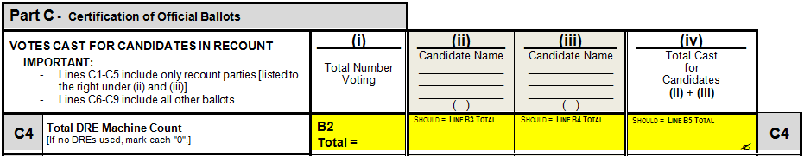

7. From Part B-1, carry over the total number of voters who undervoted this office, or voted for another candidate (last column of line B6) and enter the number in Part C, line C8 (ballots undervoted...), column (iii) (DRE).

8. Set the Statement of Results with its attachments aside for now. Return any machine printouts not attached to the SOR to Envelope #2.

D. Paper Pollbooks: Verify pollbook count and number of paper ballots cast
If paper pollbooks were used, remove the pollbook(s) and the Pollbook Count forms from Envelope #2 and examine them one at a time:

1. In Part D-1 (Paper Pollbook Count and Reconciliation) enter the division section (example "A-L") on the first line under the first "Division" column. Then enter the number of voters in the pollbook for the first pollbook division [this figure is shown on the bottom of the reverse side of the Pollbook Count form].

If a second team of recount officials will be used to hand count the paper and machine-readable ballots, that second team should perform steps 2 and 8 for each division of the pollbook.

2. Determine number of voters voting on paper ballots by examining each page of the first pollbook division, and enter the total number of paper ballots in the first Part D-1 (Paper Pollbooks) line D1-PB under the first pollbook division. (If a second team of recount officials is being used, the number should be provided to first team to enter on the form, and the entry verified by the second team.)

Paper ballot voters are those marked in the pollbook with a "P."

Outside Polls voters (marked with "OP") may have voted by paper ballot or on a portable DRE. If it is not clear from the pollbooks whether the OP voters voted on paper or machine, check the Statement of Results which will indicate each time a machine was removed from the precinct.

If the locality used a CAP to count absentee ballots, do not include the voters marked "AB" in the precinct counts unless they are also marked with a pollbook count (PBC) number.

When recounting the results for the CAP, refer to the final absentee ballot list (which serves in lieu of the pollbook) to determine the number of voters voting on DRE and by printed ballot.

3. RETURN the pollbook and pollbook count sheet to Envelope #2. Do not reseal Envelope #2 at this time.

4. If more than one paper pollbook division was used in the precinct, repeat Steps 1, 2 and 3 for each such pollbook division.

5. When all pollbook divisions have been entered, add across Line D1 (Paper Pollbooks) to total the division counts and enter the total in the last column, Total Pollbook Count.

6. Add across line D1-PB to total the paper ballot counts from the pollbook divisions and carry this number over to Part A, line A7.

7. From Part A of the Statement of Results (previously set aside), the number of paper ballot voters in the precinct is indicated in line A9 (A18 if absentee ballots were counted in the precinct). Enter this number in Part A, line A8 of the Recount Precinct Results.

8. If A7 and A8 are not the same number, ask for the advice of the Recount Coordinator. If the reason for the difference is known or can be determined by to the Recount Officials, it should be explained on the reverse of the Recount Precinct Results page containing Part A.

The Recount Coordinator may direct that the SOR and Incident Report be examined to determine possible variations in the number of paper ballots indicated on the pollbook and the SOR, and that the pollbook count sheets be examined if the pollbook officer noted paper or OP ballots.

Any other information contained in Envelope #2 may be examined by the Recount Officials at the direction of the Recount Coordinator to determine the reason for the difference.

The Recount Coordinator may also direct that the pollbooks be re-examined to redetermine the number of paper ballots cast. If the re-examination yields a different number for any division, the correction should be entered in line D1-PB under the appropriate division. When the re-examination is complete, as determined by the Recount Coordinator, the line D1-PB total must be recalculated if any division entry changed, and the figure carried over to line A7. The changes must be explained by the Recount Officials on the reverse of both changed pages.

9. From Part C1 of the Statement of Results enter the number of canceled DRE ballots in the Recount Precinct Results, Part D-1 (Paper Pollbooks), line D2 and the number of voided machine-readable and paper ballots in line D3. Add D2 and D3, and enter the total in line D4.

10. Subtract line D4 (total canceled and voided ballots) from D1 (total of division counts), and enter the figure in line D5.

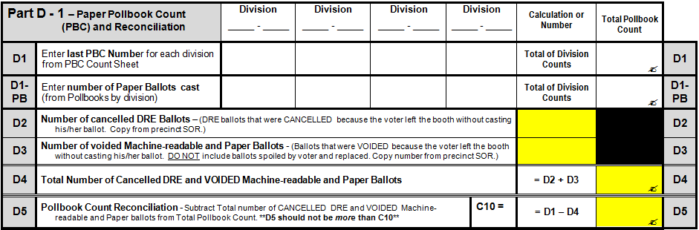

11. The Recount Officials must verify the totals entered.

12. Return all pollbooks, pollbook count sheets, the Statement of Results and any other materials removed from Envelope #2 to that envelope. RESEAL Envelope #2, with both Recount Officers signing the seal. Set Envelope #2 aside.

E. Electronic Pollbooks: Verify pollbook count and number of paper ballots cast
If electronic pollbooks were used, leave the first part D-1 (for paper pollbooks) blank, and use Part D-2 - Electronic Pollbook Count and Reconciliation.

1. If a printer was used with the EPB, remove the open/close poll report from the Envelope #2 and enter the total voters Checked-In COUNT from the report in D-2 (EPB), line D6 (total voters Checked-in Count).

If the report includes the number of voters checked in as voting paper ballots, enter that number in Part A, line A7.

2. If there is no EBP open/close poll report, it will be necessary to obtain the information from the EPB data thumbdrive sealed on election night in Envelope #2. The General Registrar, EPB manager, Equipment Technician or other person designated by the Recount Coordinators will have already loaded the precinct manager software onto a laptop and set it up in the recount room with an attached printer. (Person performing this function should also be sworn at the beginning of the recount.) One member of the Recount Team, a Recount Coordinator, and the observer from the side not being represented by that Recount Coordinator will take the precinct thumbdrive to the designated person who can bring up the data from the precinct and print the appropriate reports. The other team member and observer will remain with the precinct materials while this is done.

If the number of paper ballot voters was not recorded by the Officers in the EPB data, or cannot be retrieved, line A7 of Part A must be left blank. On the back of that page of the Precinct Recount Results, the Recount Officials must explain -- to the best of their ability-- why the data is unavailable.

3. From Part C1 of the Statement of Results (previously set aside) enter the number of canceled DRE ballots in Part D-2 (Electronic Pollbooks), line D7 and the number of voided machine-readable and paper ballots in line D8. Add D7 and D8, and enter the total in line D9.

4. Subtract line D9 (total cancelled and voided ballots) from D6 (Total EPB pollbook count), and enter the figure in line D10.

5. The Recount Officials must verify the totals entered.

6. RETURN the EPB open/close report (if applicable) and thumbdrive to Envelope #2, along with the Statement of Results and any other materials removed from Envelope #2. If a printout/report was produced from the thumbdrive during the recount, that printout/report should also be sealed inside Envelope #2 (in the event of a later contest). RESEAL Envelope #2, with both Recount Officers signing the seal. Set Envelope #2 aside.

F. Finish the paperwork
1. Return all ballots except the challenged ballots to Box/Envelope #3 (if not previously done). If manual tally sheets were used, put them in Box/Envelope #3, on top of the ballots (in case there is a contest following the recount). Then RESEAL it.

- In Part C of the Recount Precinct Results, find the totals for lines C1 through C4 in each vertical column (i - iv) and enter the column totals in the corresponding column on line C5.

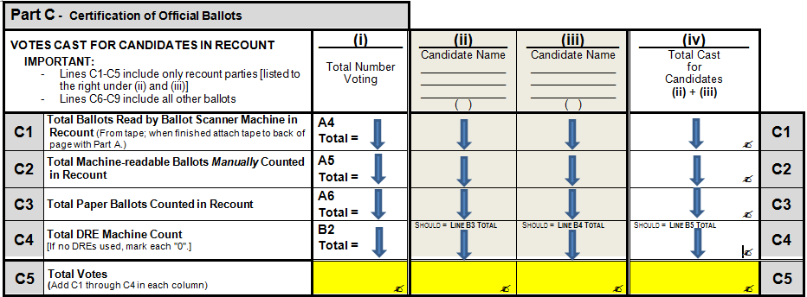

b. In Part C, add together the number of machine-readable, paper and DRE ballots (columns (i), (ii), and (iii)) in each category listed on lines C7 through C9. Enter the respective totals in Column (iv) on the same line.

- In Part C, Enter the total of column (iv), lines C5 through C9 on Line C10.

- Is the number in line C5, column (i) the same as the number in line C10, column (iv)? If not, recheck math and recheck numbers entered. Ask Recount Coordinator for guidance.
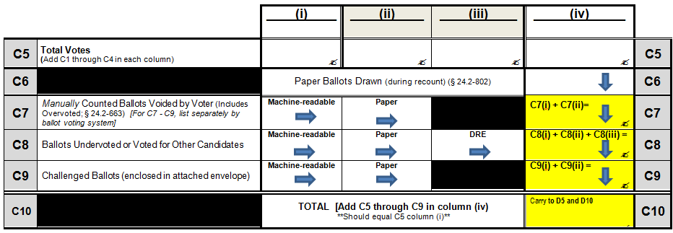

- Also enter the number on line C10, column (iv) in the proper box in Part D-1 line D5 or Part D-2 line D10 (depending on whether paper pollbooks or an electronic pollbook was used).

Paper Pollbook:

Electronic Pollbook:

2. If machine-readable ballots for this precinct were rerun through a counter during the recount, make sure that the BALLOT SCANNER MACHINE TAPE for the ballots rerun during the RECOUNT is stapled to the back (behind the top right -- see instructions on page) of the Recount Precinct Results page with Part A. Make sure that the precinct code is written on the tape.

3. Make sure that the pages of the Recount Precinct Results are complete (including all information at the top of the pages if not previously filled in) and put them in order by "Part" letter. Number the pages if this has not been previously done, or if an additional page had to be added (for example, for more individual DRE tapes than the columns available).

4. Each Recount Official must verify the totals entered and sign and date the form in the CERTIFICATION (Part E – page 1). (If a second team of Recount Officials was used to hand count the ballots, those officials must also sign the form.)

5. Staple the set of Recount Precinct Results pages together in the top left corner. If there were any challenged ballots in this precinct, staple the set of Results pages to the top left corner of the completed, sealed Challenged Ballots envelope (making sure not to staple through any ballots).

If there were NOT any challenged ballots in this precinct, DO NOT staple the Recount Precinct Results to the empty Challenged Ballots envelope. Keep the envelope until needed for a precinct that has one or more challenged ballots. (The instructions preprinted on your Challenged Ballot envelope may say to complete and seal the envelope, and staple the precinct results to it even if there were no challenged ballots in the precinct. These instructions revise those instructions.)

6. Let the Recount Coordinator know that you have completed the precinct. The Coordinator should review the completeness of the Recount Precinct Results at that time, ensuring that all entries appear to be legible (to the Coordinator), and the pages are sequentially numbered and complete.

The Recount Officials will now give the Recount Coordinator:
(1) The completed Recount Precinct Results set
- with attached ballot scanner machine tape if machine-readable ballots were rerun during the recount
- attached to Challenged Ballots envelope ONLY if there was a challenged ballot
(2) All of the election materials received from the precinct, properly resealed in their envelope/box (with any Manual Tally Sheets that were used placed/sealed inside Box/Envelope #3 on top of the ballots)
(3) The resealed memory card/cartridge used to rerun the machine-readable ballots (if applicable).

7. The Recount Coordinator will then give the Clerk of Circuit Court the completed Recount Precinct Results set with the attached tape (if applicable) and attached Challenged Ballots envelope (if used), and all other election materials for the precinct and receive the packages for the next precinct.

G. Repeat for next precinct
Repeat the above steps until all assigned precincts have been completed.

Finishing the Locality's Results; Sealing and Delivery of Material
The following steps are recommended by the Department of Elections for security, accuracy and uniformity, subject to the direction and authority of the Recount Court.

The Recount Coordinator receiving materials from the recount officials should make sure that the materials are complete.
- If machine-readable ballots were rerun through a scanner for the precinct:
  - is the recount ballot scanner machine tape stapled to the back of the Recount Precinct Results page containing Part B?
  - If any Challenged Ballots are listed in Part C, line C9 of the Recount Precinct Results form:
  - Is the Challenged Ballot Envelope attached to the Recount Precinct Results set, and has the envelope been sealed, signed, and completed?
  - Is the total number of challenged ballots listed on the envelope the same as the total listed on line C9, column (iv)?
- Do the entries on the Recount Precinct Results form set appear to be legible (to the Clerk), and are the pages sequentially numbered and complete?

The Clerk of Court for the locality will check in the materials received from the Recount Coordinator for the completed precinct. While the Recount Coordinator is present, the Clerk will make sure that the materials appear to be complete.
- Did all the election and recount envelopes/materials checked out by the Recount Coordinator for the precinct come back?
- Have all sealed materials opened during the recount been properly resealed?

Any questions should be addressed at that time to the Recount Coordinator and, if either the Clerk of Court or Recount Coordinator believes it necessary:
      - The Clerk of Court will not accept the materials in question from the Recount Coordinator at that time (checking in only those not in question), and
      - The Recount Coordinator will return to the Recount Team that prepared the materials, with the materials in question, to resolve any issues.

Once the precinct's recount materials are all accepted by the Clerk, if the locality's recount results are to be conveyed to another location after completion of all precincts, the Recount Coordinator for the locality, in the view of the Clerk of Court, will enter the total number of votes for each of the two candidates in the recount and the number of challenged ballots referred to the Court in the first line for the precinct on the Locality Summary form. Enter ZERO "0" if there were no challenged ballots. Leave the second line for the precinct blank ("challenged ballots counted by the Court").

Note: In the past this has been entirely done at the Recount Court level. In the revised process for a "two day" or "two part" recount, the Recount Coordinator will complete the first line for the precinct. The results will be checked by the Recount Court and tabulated after all challenges have been decided.

The Clerk of Court will place the recount materials to be conveyed to the Court for the locality as a whole in precinct number order, to be placed in the Locality Results Envelope when completed.

The Clerk of Court will then give the Recount Coordinator the materials for the next precinct (checking them out as given).

The Clerk of Court will replace the sealed materials for the election that will remain in the locality in a secure place with the other completed materials.

The Recount Court may be in session in the same room while the recount is underway, and may choose to review the precinct results and any challenged ballots (or just the challenged ballots) as each precinct is completed. If the Clerk of Court is instructed to convey these immediately to the Recount Court, it is recommended that the Clerk note on the materials check in/out record what was given to the Court, when it was received, and who received it.

If the Recount Court decides to review precinct results and challenged ballots as the precincts complete them, the Court or its designee would enter the total number of votes for each of the two candidates in the recount and the number of challenged ballots referred to the Court in the first line for the precinct on the Locality Summary form, entering ZERO "0" in the last column if there were no challenged ballots. The court would record its decision(s) on the challenged ballots on the second line for the precinct ("challenged ballots counted by the Court") on the Locality Summary form.

If the Recount Court decides to review only the challenged ballots as the precincts are completed, the Clerk would give that envelope to them with the attached precinct results. After reviewing the challenged ballots (without reviewing the Results), the Court would note its decision on the outside of the envelope by candidate (for example "Smith - 2, Jones - 1, not counted - 1), reseal the envelope and return it to the Clerk for the locality to put with the other completed recount precinct results.

Repeat the above steps until all assigned precincts have been completed.

"Part Two" - Court Review and Compilation of Results -- Suggested Steps

Check in and Logistics
Make sure you have the following documents and materials:
- Locality Summary of Recount Results (SBE-802-LS)
(one form has been prepared for each locality)
- Court Certification of Recount Form (SBE-802-CC)
(lists results by locality)
- Locality Results envelope/box for each locality
- Stickers to reseal the envelopes
- Notepads
- Pens

Officials and Authorized Representatives
Floor Teams:
  - One Department of Elections Staff Member,
  - One representative of the accounting firm,
  - One representative of each campaign.
Duties: Open locality results envelope/box received from runner one locality at a time. Handle challenged ballots. Report challenged ballots. Determine precinct results from the materials submitted by the locality. Complete Recount Certification – County or City Results by Precinct (SBE 802-LS) form for the locality being examined.

Floor Attorneys:
  - Attorneys for each campaign
Duties: Available to Floor Teams to answer questions and resolve issues.

Appeals Team:
  - Lead attorneys for both candidates,
  - Department of Elections senior staff,
  - Member of the Clerk’s staff (at Clerk’s option).
Duties: Resolves any issues raised by Floor Teams. Issues are resolved if the two party attorneys are in agreement, and the Department of Elections senior staff member bears witness to the agreement. Any issues not resolved by the Appeals Team will go to the Recount Court for a decision. Examine challenged ballots that could not be resolved by the Floor Team and refer to Recount Court for its decision (with recommendation if one is reached). Examine materials (pollbooks, ballots, etc.) referred to the Recount Court when number of paper ballots in a precinct does not equal the number of paper ballot voters on the pollbooks, or there are other problems.

Summary Team:
  - One Department of Elections Staff member,
  - One representative of the accounting firm,
  - One representative from each campaign.
Duties: Examine Recount Certification – County or City Results by Precinct (SBE 802-LS) for each locality as received from the runner. Total columns and enter totals on Summary form for the locality. If any challenged ballots that could not be resolved by the Floor Teams are later counted by the Court, add them to the Summary form under the locality (not on the Results by Precinct form) and recalculate totals.

Runner:
  - One Department of Elections Staff member
Duties: Take the materials from the Clerk, one locality at a time to the Floor Teams, pick them up when the Floor Team is finished, return the materials to the Clerk, and deliver the tabulation sheets to the Summary Team.

Clerk
Duties: Clerk or Deputy Clerk should maintain control of the recount room, including press and general public, hand out locality documents and receive them back when completed, and transport any challenged ballots unresolved by the Floor Team or Appeals Team to the three judges of the Recount Court for their decision.

Floor Team Step-by-Step

Guidelines
- ONLY ELECT STAFF may handle ballots or other materials.
- Ensure all members of Floor Team and any observers are able to see the materials clearly.
- If, at any time, the packet is missing information or does not comply with the requirements set forth below, notify the Appeals Team (ELECT Executive/Policy Staff or Campaign Attorneys).

Review and Compilation of Results
Local Results envelopes/boxes received from localities should be alphabetized by locality to make sure that they are present and clearly marked. If a county and city have the same name they should be marked to show the county or city designation before the recount begins.

- Floor Team Receives Locality Materials from the Runner

  - Check to ensure the Clerk or Deputy Clerk of the Locality’s Circuit Court has signed in the space provided in the lower right hand corner of the package.

  - Check for SBE-802 LS form: “Recount Certification County or City Results by Precinct” (tabulation sheet).
    - If there is no 802 LS form, the accountant will have to create a form from a blank 802 LS.

  - Count the number of SBE-802 PR forms “Recount Precinct Results for All Voting Systems”.
    - Number of forms should equal number of precincts listed on tabulation sheet (SBE-802 LS + 2 for CAP and provisional ballots, if locality has a CAP).
    - Also confirm precincts with spreadsheet of precincts provided.

- Open Recount Precinct Results to Part C (SBE-802 PR).

  - Confirm Line C5, column (ii) and (iii) of SBE-802 PR correspond with precinct totals entered on Recount Certification (SBE-802 LS) for each candidate.

  - Confirm number of challenged ballots entered on Line C9 of SBE-802 PR correspond with number of challenged ballots entered on SBE-802 LS.

- If any information does not match, please notify a member of the Appeals Team.

Dealing with Challenged Ballots

- Open the package.

  - Remove one envelope at a time.

  - Ensure there is an 802-CB attached to a Challenged Ballot (CB) Envelope.

  - Ensure the 802-CB is signed by the Recount Officials for that precinct.

  - Identify precinct and locate the precinct on the Recount Certification – County or City Results by Precinct form.

- Examine the CB Envelope

- If zero indicated on front of envelope, hold envelope to the light and ensure envelope it is empty.
    - Accountant shall enter ZERO on the 802-LS

- If a number is indicated on front of envelope, open the envelope and verify the number of ballots included equals the number indicated on the form.

- Accountant should enter the number of ballots challenged on 802-LS
      - Ensure each challenged ballot has an 802-CB attached to it.

- Allow each party to examine, but not handle, the challenged ballot one at a time. (if there is any question, refer to the Department of Elections Ballot Examples)

- If the two Party Representatives agree on which candidate the ballot should be counted for, then mark on the back of the 802-CB the name of the candidate the candidate for which the ballot shall be counted for.

- If the two Party Representatives do NOT agree, then request the Appeals Team over to review the ballot.
        - If parties agree, then follow procedure above for counting the ballot.
        - If parties do NOT agree, then provide the ballot to the Runner who will take it to the Clerk for review by the Court.

- If no number is entered on front of envelope, open to verify if the envelope is empty.

- Review 802-PR to find the number of ballots challenged.

- Accountant should enter the number found on 802-LS.

- If a challenged ballot is present, allow each party to examine, but not handle, the challenged ballot one at a time. (if there is any question, refer to the Department of Elections Ballot Examples)

- If the two party representatives agree on which candidate the ballot should be counted for, then mark on the back of the 802-CB the name of the candidate the candidate for which the ballot shall be counted for.

- If the two party representatives do NOT agree, then request the Appeals Team over to review the ballot.
- If parties agree, then follow procedure above for counting the ballot.
- If parties do NOT agree, then provide the ballot to the Runner who will take it to the Clerk for review by the Court

- Finalize the Locality Results

- Once all ballots have been determined, the accountant will complete the 802-LS.
- ELECT staff and the party reps should confirm the 802-LS is entered correctly and initial under the totals.

- Call a Runner to take the 802-LS to one of the Summary Teams.

- Call a Runner to take the locality materials back to the Clerk.

Final Certification of Results: Re-seal material
After the Floor Team has completed the 802-LS Recount Certification – County or City Results by Precinct, the materials are transported to the Summary Team.

- The Summary Team checks the math and completeness of the Locality Summary of Recount Results (SBE-802-LS).
- The Summary Team transfers the vote totals for each candidate in each locality from the Locality Summary of Recount Results (SBE-802-LS) to the Court Certification of Recount (SBE-802-CC) form.
- The Summary Team transfers any information regarding challenged ballots (SBE-802-CB) received from the Appeals Team or the Recount Court on the Court Certification of Recount (SBE-802-CC) form.
- The accountant on the Summary Team verifies the accuracy of the Court Certification of Recount (SBE-802-CC) form.
- The Court Certification of Recount (SBE-802-CC) form is submitted to the Recount Court for their certification.

After the Recount

Issuance of Certificate of Election
The person having the highest number of votes shall be deemed to have been elected to such office and shall receive a certificate of election. The Attorney General’s office has determined that the certificate of election should be issued by the local electoral board even though an election is being recounted. There are no provisions of §24.2-802 that would delay the local electoral board’s issuance of the certificate of election as required by §24.2-676.

If the Court’s certification of the recount declares the losing candidate the winner, a new certificate of election must be issued, making the original certificate null and void.

Update Results on Department of Elections Website
Localities involved in a recount may need to change their election results. §24.2-671 requires there to be a record of all changes to vote totals made after Election Day. Therefore, all localities must enter a “Reason for Change” in VERIS before they can change their vote totals. These changes will be reflected on the Department of Elections website. The Department of Elections generally does not publish local results since they are not the certifying agent. However, since most local elections are held on an Election Day in which the Department of Elections is the certifying agent, local office results are included. The website will be updated accordingly.

Return and Final Retention of Material
All of the recount material received from each city or county comprising the district being recounted should be resealed and signed by the Recount Court's designated officers tabulating the results, and preferably also by representatives for the parties to the recount if present, and then securely stored by the Clerk of Court for the Circuit Court in which the recount was held. These materials should remain secured and sealed until the time for the candidate losing the recount to initiate a contest has expired. See Contests near the beginning of this document and § 24.2-814 allowing 10 days from recount court order declaring winner to file contest.

If the recount was for a primary or election for a General Assembly seat, statewide office or federal office, the Department of Elections will check with the appropriate office to determine if a contest has been filed by the deadline, and then notify the Clerk. If no contest is pending, the records for the Clerk's own locality should then be treated as prescribed by law for other records from that same election date that are in the custody of the Clerk.

Materials sent from any other localities in the district to be recounted should be returned to the Clerks for those localities, again to be treated in the same manner as other records from that election date that are in the custody of the Clerk. The other Clerks may want to pick up the records, or the sending Clerk may have them delivered personally or by a method that includes tracking of delivery. If the materials are picked up or delivered personally, both Clerks should keep a record documenting the transaction.

In the case of a primary or election for a county, city or town office, or local district office, any contest would be filed with the Circuit Court where the challenged candidate resides. Unless the recount was for a shared local office, the Clerk of the Court that conducted the recount will receive any contest filed, or should check with the Clerk where the winning candidate resides to determine if a contest has been filed by the deadline.

David M. Drucker & Emily Pierce, “Democrats May Join Minnesota Fray,” Roll Call, 12/8/08
In the event of a U.S. Senate recount in Virginia, Department of Elections would ask the Parliamentarian of the Senate (through the state's other Senator(s)) if the rules at that time specify a deadline for filing a contest after the conclusion of a recount.
If the recount is for a referendum, insert title of the question involved in the recount and its two separate responses, instead of the office and candidate names.

