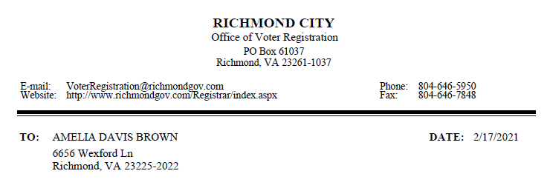

The Permanent Absentee Ballot application received on <dd/mm/yyyy> that we had on file for you at the Virginia Department of Elections has been cancelled in accordance with Virginia Code @24.2-703.1(D) for the following reason:
<ABSENTEE STATUS REASON>

Effective immediately, you will no longer automatically be sent absentee ballots for elections in which you were previously eligible to vote, based on the permanent absentee ballot application referenced above.

If you have any questions about this notification, please contact this office.

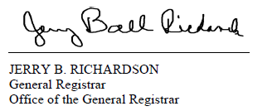
Not on the correspondence but requested for translation:
(Absentee Status Reasons)
Voter Registration Cancelled
Voter Registration Status Inactivated
Voter Registration Transferred to Another Locality
A new ongoing application subsequently approved

