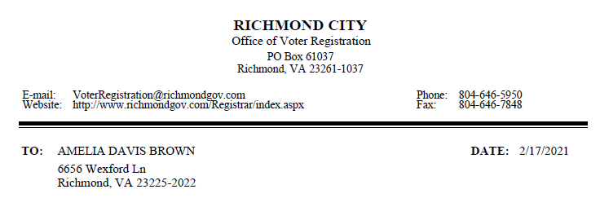

Your Permanent Absentee Ballot application submitted on <dd/mm/yyyy> has been approved.

Effective immediately, you will automatically be sent absentee ballots for all elections in which you are eligible to vote. We will determine which ballots you are eligible to receive based on the information you provided when you registered to vote. An absentee ballot will be sent to you by <Ballot Sent By> starting 45 days prior to each relevant election.

If you have any questions about this notification, please contact this office.

