Vote-by-Mail Instructions

To ensure your ballot is counted, read these instructions!
Except as provided below, the law requires that a witness must be present for steps 1 through 3 listed below. Any person can serve as your witness.
- If you believe you may not safely have a witness present while completing the absentee ballot for the November 3, 2020 elections, you are not required to have a witness present for steps 1 through 3 listed below.
- Accordingly, you may disregard the witness signature line on Envelope B if you believe you may not safely have a witness present while completing your ballot.

How to Vote by Mail
Important: If you decide to vote in person at your polling place on Election Day, take your uncompleted ballot with you to the polls.
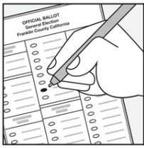
If you would like to vote in person before the election at the Office of the General Registrar or a satellite location, take your ballot with you.

1. BEFORE opening Envelope A, you must find a witness to watch you open Envelope A containing your ballot
- Your witness can be anyone age 18 or older who is not your employer.

2. Open Envelope A and mark your ballot
Make sure to:
- Open Envelope A in front of your witness. (Your witness should not watch how you vote.)
- Follow the instructions on the ballot to record your votes. Use blue or black ink to fill in the ovals completely to mark your choices. If you do not wish to vote for any of the candidates in a contest or do not want to vote for an issue, skip that office or issue and leave the ovals blank.
- Vote only for the number of candidates allowed.
- If you make a mistake or lose your ballot, contact your general registrar’s office for more information.

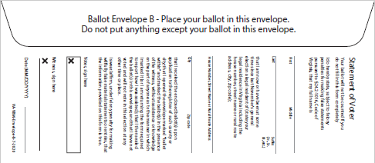
3. Complete Envelope B, sign, and seal
Follow the instructions on the envelope. Make sure you:
- Place your ballot in Envelope B and seal it.
- Write your full name.
- Write the address where you are registered to vote.
- Sign the envelope. If you are unable to sign, you must return a “Request for Assistance” form. See the back of this form for more information.
- Have your witness sign the envelope.
Important!
- Unless you believe you may not safely have a witness present while completing the absentee ballot for the November 3, 2020 elections, Envelope B must be fully completed, including both the voter and the witness signatures or your ballot cannot be counted.
- Your ballot must be inside Envelope B, or your ballot cannot be counted.
4. Return your ballot
- Turn this form over to learn how to return your ballot and how to mark your ballot if you need assistance.

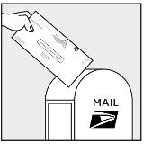
You may return your ballot by mail or in person:
- Mail your ballot so that it is postmarked on or before Election Day, using either:
  - The United States Postal Service (USPS). Be aware that you do NOT have to put stamps on your return envelope.

OR
  - A commercial delivery service, including but not limited to, UPS, FedEx, and DHL. (The ground address for commercial delivery service is: [enter the street address of your office here.])

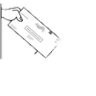
- Deliver your ballot in person to the general registrar’s office (see address above) or a member of your local electoral board before 7:00 pm on Election Day.

  - We are open 8:00 am – 5:00 pm Monday – Friday and the two Saturdays prior to the election. Find more information on our website. All contact information is located at the bottom of this form. You can also utilize a drop box location (see more information below).

IMPORTANT INFORMATION REGARDING DROP-OFF LOCATIONS
For the November 3, 2020 elections, you may deposit your completed absentee ballot at any of the drop-off locations in your county or city. You can find a list of drop-off locations in your county or city at this link: www.elections.virginia.gov/casting-a-ballot. You may also drop-off your absentee ballot at your polling place on Election Day. Note that your completed ballots must be returned in Envelope B, signed, and sealed.
______________________________________________________
If you indicated on your application that you need assistance marking your ballot
- We have included a Request for Assistance Form.
- If you need assistance voting your ballot but did not receive a Request for Assistance form, contact your general registrar’s office to have one mailed or emailed to you.
- If you are print disabled (e.g., blind or have low vision or impaired manual dexterity) and would like to vote using an electronic ballot marking tool, contact your General Registrar using the information below.
- You and/or your assistant must complete the Request for Assistance form before you vote.
  - If you are unable to sign, your assistant must write “voter unable to sign” on the voter’s signature line.
  - If you are blind, your assistant must write “blind voter” on the voter’s signature line.
  - Assistant: print your name and address in the assistant section, then sign and date.
- Place your Request for Assistance form in the return mailing envelope. Do not put the form in Envelope B with the ballot.
- Assistant: if the voter is unable to sign, you must also write “voter unable to sign” on the voter signature line on Envelope B.
- If you no longer need assistance, do not return the form.
__________________________________________________________________________________
We’re here to help! Contact us with any questions.
- Check our website: [insert your website URL]
- Track your ballot here: www.elections.virginia.gov/casting-a-ballot/absentee-voting/
- Send us an email: [insert your email address]

- Reach us by phone: [insert your phone number]
Stop by our office to ask questions or get forms: [insert your GR address here
City, zip code, etc.

